Meta Description:
Learn everything related to Link building for SEO. From what it is, what strategies to follow, and what strategies to avoid, Read and become an expert in the field.

Link Building for SEO: A Guide for the Beginners
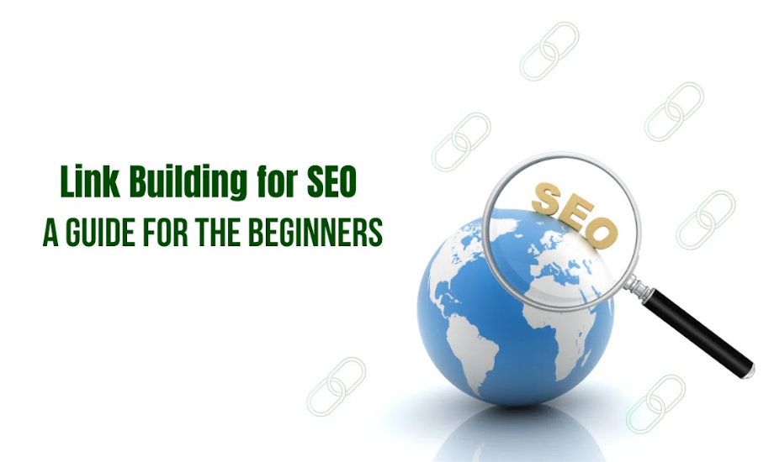
Link building is a vital component of Search Engine Optimization when it comes to establishing authority, gaining ranking, and driving organic sales. In recent times link building for SEO has redefined the arena of marketing.
Here in this beginner guide, what link building is, why you should add links to your SEO strategies, and also know about shortcomings to avoid and put at your disposal methods to control your progress. Let’s arm up and go through intensive learning on how to increase your link-building aspects.

1. What Is Link Building in SEO?
Link building can be defined as the process of gaining hyperlinks from other websites. It is not only helpful to increase the authority of your site but also to enhance the ranking of your site in the search engines.
Link building remains one of the centers of any SEO campaign to this day. It entails the process of getting other websites to link to yours as this is seen as a vote of confidence. Google and other search engines view these links as a sort of endorsement so this will make your site more authoritative or authoritative.

How Search Engines Evaluate Links?
Search engines apply certain methods when scoring page quality and relevance of backlinks. This includes practices like analyzing the number of links, the quality of the sites linking to your site or the relevance of the content.

Internal vs. External Links:
Internal links are those that take the users within the same site. In internal linking, you can connect your website web pages internally. They help users and search engines to navigate to other parts making the site more optimal. While external links refer to links from other websites that refer to yours. These are essential for the enhancement of the site’s accreditation and ranking among the search engines.

2. Factors Influencing the Value of Backlinks
Information about the factors that are tied back to the value of backlinks would go a long way in implementing proper link-building techniques. Let's explore these key factors:
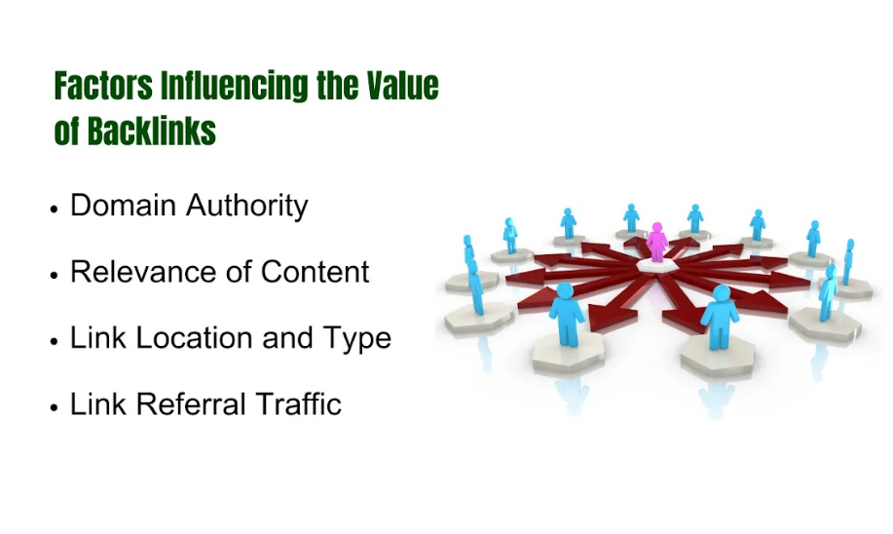

2.1. Domain Authority:

What is Domain Authority?
Dominance is a metric created by MOZ used in predicting how a website might do on the actual search engine result pages. It means that the greater the DA of the site, the more its content can be considered credible and reputable.

Impact of Domain Authority on Backlink Efficacy:
It is worth remembering that links from sites with high DA have more value and can promote the strengthening of your site’s position. It also provides cues to search engines that want to know if the content is trustworthy or not.

Assessing Linking Site Authority:
In the analysis of the site’s relevance and trust, examine the sites’ DA, traffic rates, and past activity and performance of published materials. Some of the tools such as Moz’s Link Explorer can give information concerning a particular site DA.

2.2. Relevance of Content:
Relevance refers to the kind of content that can be used in building links and should not be overlooked. Links from similar categories or niche sites are considered more important as they suggest the relevance of the site to the topic or industry it is concerned with.

Enhance Link Value Through Relevance:
If your website is based on digital marketing services in Dubai, a backlink from another website that is also oriented in marketing strategies will be more valuable than a backlink from a food blogging site.

2.3. Link Location and Type

Types of Links: Dofollow vs. Nofollow
- Dofollow: Truly, these are the links that can pass the link juice so the website earns a high ranking in the search engine.
- Non-followed Links: These are the links that do not accept the passing of link juice. They are primarily used in Blogs or other user loads of content and in link exchanges that are prohibited to skew the ranking system.

Placement and Visibility:
The placement of a link means that the link will provide the desired results when it is placed on the right. You will see the links placed deeply in the content body, in the headers, in the sidebars, and the menus as valuable as links placed in the footer of the website or the comment section.

2.4. Link Referral Traffic
Although backlinks are very important for enhancing SEO, they also bring traffic directly from the links used by other sites. Backlinks from such popular portals would help to attract a large number of visitors to your material.

Strategies for High-Traffic Link Acquisition:
Website with a high level of activity and ranking. These are valuable links that can be obtained by guest blogging, creating graphics that can be shared, or contributing to webinars.

3. Effective Strategies for Links-Building (and What to Avoid)

3.1. Proven Techniques for Building Quality Links
If you want to build quality links then you have to follow White-hat SEO where you seek to follow Google rules and guidelines. Here are some proven White-hat SEO techniques for link building:
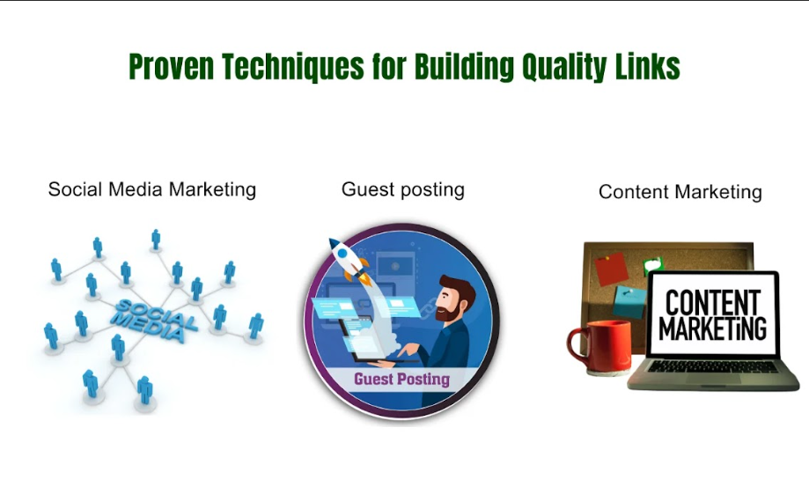

Social Media Marketing:
Popular opinion is that social networks are a great way to establish connections with industry influencers that might lead to numerous link prospects. Twitter is by far the most used one and it can also be useful to build connections with influencers, boost their posts, and offer cooperation. This is because genuine interaction can eventually result in the process of back-link exchange.

Guest posting:
This strategy has the advantage of being recognized as an expert in the field by getting quality backlinks from well-established websites. Concentrate on those areas that would be relevant to your readers and always make sure that your posts are valuable to them.

Content Marketing:
Produce high-quality shareable content that would invariably attract links. For content marketing, you can rely on infographics, in-depth guides, and case studies to get links back to your site.

3.2. Common Pitfalls in Link Building
When creating or getting links you must avoid the black-hat practices that are detrimental to link building. Here are some common pitfalls you can avoid when you are going to buy or exchange links

Buying Links:
There are a number of links for sale on the market but this is very risky and can attract the search engines’ penalties. Google crawlers are very efficient in detecting unnatural links and have presented specific instructions to guide webmasters on how they should prevent such links from being posted.

Link Exchange:
Getting involved in link farms where numerous websites are linked with each other for purposes of improving their ranking and ratings is very much a risky affair. Such links may be irrelevant and fake in many cases.

Unrelated niche links:
Getting links from an unrelated niche is a counterproductive method for search engines as they are not sure of the kind of site they are dealing with. This may affect the rankings of the site.

4. Monitoring Your Link Building Progress:
Therefore, if you have been undertaking link-building for your site, it is crucial to measure performance and make informed strategies. This way you can save yourself and your website from a lot of trouble.

4.1. Key Performance Indicators (KPIs)
Make sure you identify specific KPIs that are affecting the efficiency of your link-building strategies. Here are some factors you can consider to measure the KPIs effectively:

- Domain Authority: To check on specific changes in domain authority to see how your link profile is affecting the site’s authority.
- Organic Search: Monitor changes in organic search and correlate them with the new links in order to get a picture of their visibility.
- Backlinks: Determine the sources of backlinks to know which gives the most referral traffic.

4.2. Link Audit Tools
It is very important to use link audit tools in the process of shaping and maintaining your link profile. Here is how you can get the best from tools to ensure that your employees become the best:

- Use the Right Tool: Use the right tool depending on the type required such as Ahrefs, Moz, or SEMrush.
- Set Up Alerts: It is important to set up alerts that will inform you the moment there is a new link or even a new link profile that has cropped up or there is a change.
- Weekly check: Once a week, check the link profile to disable the links that can be harmful to the website’s reputation. All in all, this proactive approach helps you to sustain the site’s credibility.
- Analyze Backlink Quality: Determine the quality of your backlink by assessing the Website Authority of the sites that are linking to your site.

5. Top 9 Link-Building Strategies to Implement
Link-building strategies are effective ways to boost your SEO. Given below are the top 9 link-building strategies that you need to implement if you want to build the trust and credibility of your website in the eyes of the customers.
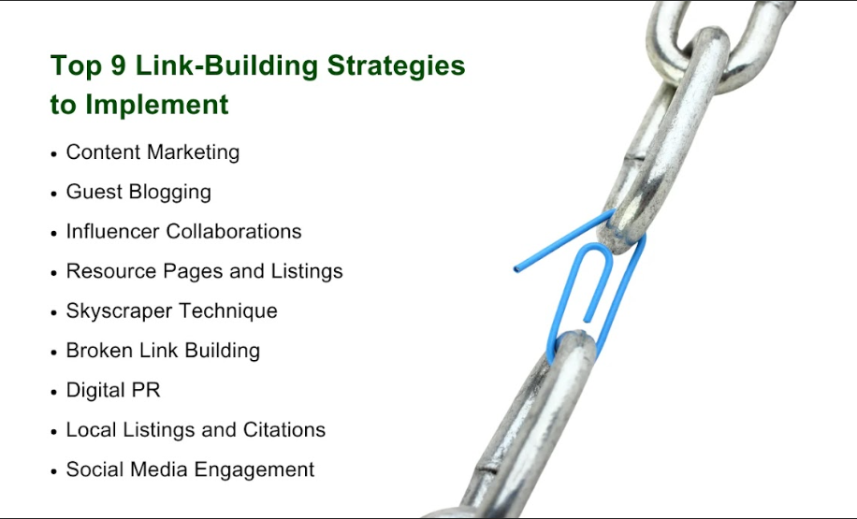

5.1. Content Marketing
There is an effective adage in the business world today which is ‘content is king’. Professional and unique content always attracts links naturally because people will want to share such material with others. That’s why you should provide high-quality content that is informative, interesting, and easily shareable to attract natural links.
All your articles, blogs, videos, and infographics should be informative to the audience you are targeting. So, make sure you create as unique and relevant content as possible to be linked to other websites.

5.2. Guest Blogging
The blogging technique is still popular because of its effectiveness in link-building. Guest posts related to the industry would help your website reach out to more readers and build backlinks as well. Contact reputable blogging sites in your specific niche as a method of creating value for your readers. Your guest posts should contain a backlink to your site because it will help improve the rank of your site in search engines.

5.3. Influencer Collaborations
Working with influencers helps achieve many objectives related to promotion, but in link-building it is also efficient. Promote your business and share content with other officials’ pages that are popular and relevant to your business. Indeed, you can provide them with articles to write about or goods to use to ask for a link back to your site in exchange. In addition to creating backlinks, influencer endorsements help develop a good reputation and expand the business reach.

5.4. Resource Pages and Listings
It is always resourceful to learn that to get backlinks you can turn to pages with lists of links and internet directories. These pages sometimes provide useful links connected with particular subjects. As a website owner, you should locate the directories and resource pages within your particular field of interest and list your site. This will assist you in restoring the backlinks of your website and enhance its recognition among professionals and the audience.

5.5. Skyscraper Technique
The Skyscraper Technique is a great technique that helps to increase the reach of your content drastically. Begin with keywords that have huge numbers of backlinks and are presently famous in your subject area. Focus on understanding the kind of content that made the author successful, and then provide better content that the author could not deliver.
When the above steps are input to the content and made to look presentable, you should contact the same sites that linked to the content and request them to link to the enhanced content. This technique uses the profiles of the backlinks already set to attract more visitors and business to the website.

5.6. Broken Link Building
The main advantage of broken link building is that it tends to remain subtle yet has a substantial impact falling more or less under the radar. It entails recognizing dead links on other websites and recommending that they use your content instead.
Locate these broken links with the help of the available tool and then send a nice email to site owners. Give the website owner an opportunity to get your content as your offer is beneficial to both the site owner and his visitors and at the same time get a link back to your site.

5.7. Digital PR
Digital PR focuses on generating buzz around your brand through newsworthy content and outreach. Writing interesting company stories or press releases, which cover a gist of what the company has accomplished, a new product or service that is in the market, or perhaps the company’s contribution to society. Share these stories with journalists, bloggers, and industry influencers. This way you have a better likelihood of being included in the articles or posts that contain backlinks to your website making your brand more prominent.

5.8. Local Listings and Citations
Local SEO is useful for any organization that has operations in a particular locality or region. Getting local listings and citations helps improve your local search engine visibility. For instance, make sure your business appears on Google My Business, Yelp, and Yellow Page, among other business listing sites. Correct citations in these directories make a small, yet significant, improvement to local SEO and help you earn more backlinks from local sites and directories.

5.9. Social Media Engagement
No tool in the modern world would be as effective in raising sales or a company’s profile as social media can be in backlinks. Be active on social channels such as Twitter, Facebook, LinkedIn, and Instagram. This is a great way of sharing your content, engaging with your audience, as well as discussing matters relating to your material. Contrary to the fact that social media links are considered no-follow, they can help drive traffic to your website and compel other officials to link to your content, which helps in expanding the range of authorities and possible backlinks.

6. Essential Tools for Link Building
It is recommended to follow a step-by-step approach when making the link-building process fast and efficient. Here are some suggested tools that can be used in link analysis, tracking, and outreach:

- Ahrefs: Comes equipped with several research features such as analysis of backlinks as well as keywords along with the analysis of competition. Ahrefs is also very useful in terms of finding new opportunities for link building and analyzing backlink indexes.
- Moz: It provides features such as site auditing, keyword tracking, link building, and other features with a graphical user interface. It is especially helpful in using Link Explorer to evaluate your chosen site’s backlinks and discover new possibilities.
- SEMrush: This is one of the most used tools for professionals in SEO, PPC and content marketing. In the current context, Backlink Analytics in SEMrush picks out your backlink portfolio and defines prospective link-building opportunities.
- Linkody: It is one of the tools for backlink checkers. Linkody also notifies whenever links are either gained or lost and this alerts the SEO to attend to the backlink profile.

All of these tools are quite useful for link building because each tool has its own features that meet certain requirements of SEO.

7. Begin Your Journey to Quality Link Building Today
Before we move to the final stage of this guide, you should bear in mind that link-building is not a one-time endeavor. You should ensure that you put into practice the strategies discussed earlier, also avoid the pitfalls, and use relevant tools available to monitor the level of progress. On the same note, authenticity over quantity and maintaining honorable business ethics should be embraced.

Final Thoughts:
The strategy of link building is more long-lasting and the results are sustainable for your website, in terms of traffic from the search engine. Make sure that you are well informed and up to date on changes in SEO trends because it is not time to play, but to play to win.
It’s now time to add an improvement to your link-building prospects. Therefore, if you need link-building services or any form of website promotion services, kindly feel free to contact Three Angle Marketing for the best services to offer. Our team is ready to assist you in handling the complexities of SEO and get you on the right track towards your online marketing success.

